Definition:
Recommender systems are algorithms designed to predict user preferences and make personalized recommendations. These algorithms can be based on various criteria, including past purchases, search history, demographic information, and other factors.
Our Task:
Recommender system for movies, based on a record of movies already seen by each user.
There are many possible implementations for recommender systems. We explored the Collaborative Filtering method, and used NNs to model the user item interaction.
We explored the Collaborative Filtering method, with a model-based approach with deep learning algorithms. Which means the algorithm recommend items based on the preference of similar users.
- Content-based methods uses attributes of items to recommend to users new items similar to what the user has liked in the past (doesn't take into account the behaviour of other users);
- Collaborative Filtering methods uses similarities between users and items simultaneously to determine recommendations;
- Hybrid methos mix content-based and collaborative filtering approaches.
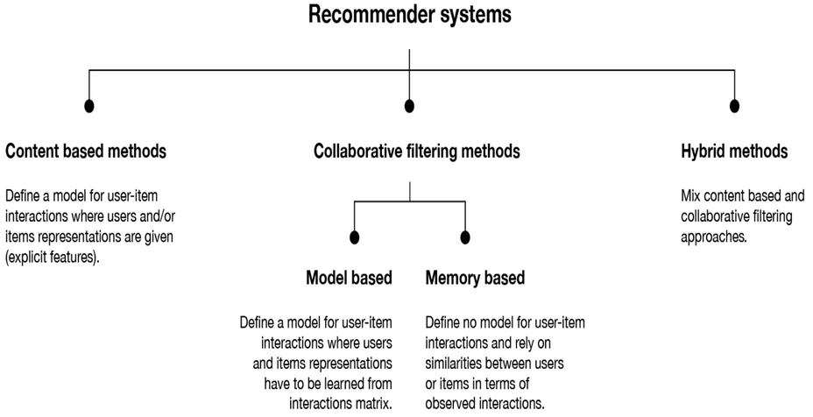

We model the problem as a binary classification problem, where we learn a function to predict whether a particular user will like a particular movie or not. The model takes in two sparse vectors, one representing the user and the other represents items. Basically both items and users are one-hot encoded. These two vectors should be passed to a first embedding layer (to project sparse representations to dense ones). These embeddings can be seen as a latent vector for users and items.

Metrics
We use Hit Ratio (HR), and Normalized Discounted Cumulative Gain (NDCG) to evaluate the performance. HR is simply the fraction of users for which the correct answer is included in the recommendation list. NDCG is a measure of ranking quality. The gain is accumulated from the top of the result list to the bottom, with the gain of each result discounted at lower ranks.
While training, we will be minimizing the cross-entropy loss, which is the standard loss function for a classification problem.
To evaluate the model we used the following metrics:
Hit Ratio which is the fraction of users for which a correct recommendation is included in the recommendation list.
Normalized Discounted Cumulative Gain which is a measure of ranking quality.

Generalized Matrix Factorization (GMF)

Generally Matrix Factorization (MF) algorithms associates each user and item with a real-valued vector of latent features.
Let pu and qi denote the latent vector for user u and item i, respectively; MF estimates an interaction y_{ui} as the inner product of pu and qi
MF models the dimension of the interaction of user and item latent factors, assuming each dimension of the latent space is independent of each other and linearly combining them with the same weights.
This imposes some limitation of MF caused by the use of a simple and fixed inner product to estimate complex user-item interactions in the low-dimensional latent space.
In order to overcome this limitation, we can build a Generalized Matrix Factorization (GMF) algorithm where we can weight the linear combination (with a linear layer) of the element-wise product and use this with an activation function (sigmoid) to learn a representation of the input insted of using a fixed one.

Neural Collaborative Filtering
GMF learn user and item embedding separately. To empower the model it is possible to combine the features of two pathways by concatenating them and passing this concatenation to a Multi-Layer Perceptron (MLP) to learn the interaction between user and item latent features. This model is known as Neural Collaborative Filtering (NCF)
The input to the model is userID and itemID, which is fed into an embedding layer. Thus, each user and item is given an embedding. Then there are multiple dense layers afterward, followed by a single neuron with a sigmoid activation.
The output of the sigmoid neuron can be interpreted as the probability the user is likely to interact with an item.

Neural Matrix Factorization

So far we have developed GMF that applies a linear kernel to model the latent feature interactions and MLP that uses a non-linear kernel to learn the interaction function from data.
How can we fuse GMF and MLP under the NCF framework, so that they can mutually reinforce each other to better model the complex user-item interactions?
A straightforward solution is to let GMF and MLP share the same embedding layer and then combine the outputs of their interaction functions.
To provide flexibility to the fused model we want to allow GMF and MLP to learn separate embeddings and combine two models by concatenating their last hidden layer.

● Generalized Matrix Factorization:
Estimates the interaction through the inner product of the embeddings of user and item.
● Neural Collaborative Filtering:
Combine the features of the two embeddings by concatenating them. Use a Multi-Layer Perceptron (MLP) to learn the interaction.
● Neural Matrix Factorization
we combine GMF and MLP by concatenating their last hidden layer, so that they can mutually reinforce each other and better model the user-item interactions.

